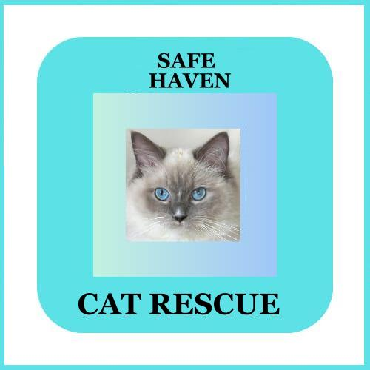

**CAT REHOMING APPLICATION**

Title: First Name: Last Name:

Address

County: Postcode:

Email:

Phone (home )

Phone (mobile)

**ARE YOU INTRESTED IN:**

Fostering or Adopting?

Specific Gender?

Number of Cats? (pair of kittens/cats, single cat, etc)

Age Range?

Have you seen a cat or kitten on our website that you are interested in ? If so tell us the name.

**A LITTLE BIT ABOUT YOUR HOME** :

Do you own or rent?

Do you have a garden?

What provision do you have for allowing the cat outside?

**A LITTLE BIT ABOUT YOUR FAMILY:**

Give details of who lives at home:

Give details of any frequent visiting children

Do you own other cats?

Give details of any other pets that live in the home

Give details of any visiting animals (if any)

Have all members of your family been in contact with cats before? ( to rule out allergies)

**A LITTLE BIT ABOUT YOUR LIFESTYLE**

Give details of how long the cat will be on their own:

**YOUR IDEAL CAT**

Give details of your ideal Cat:

Do they need to be:

-Good with cats, dogs,

-Comfortable around children,

-Be litter trained,

-Enjoy being picked up/ petted,

-Enjoy playing with toys,

-An indoor-only cat.

**YOUR EXPERIENCE**

Give details of your experience of owning a Cat. Is this your first Cat?

Date of Application

Whilst every care is taken to find the right cat for you, we cannot guarantee behaviour, nor can we

guarantee that we will have a cat suitable for you.

**We have a rehoming fee of £70 per ca**t. All our cats are neutered and if not neutered at the time of rehoming will be required to be neutered as soon as permitted by a vet. All adoptions will only take

place following meeting the cat at the foster home and a home check.

We will be in contact as soon as we can. Please be patient as we are a small organisation with low

staffing numbers and deal with a large influx of calls and emails every day.

We will be doing a monthly check for first 6 months.

Also at 6 months we will carry out another home check.